**Alert Notification Use Cases for Elite Equine Marketplace**

**Ad Viewer Alerts:**

* When a new listing matches their saved search criteria (Trigger alert immediately)
* When an auction they are bidding on is ending soon (Trigger alert within one hour of auction ending)
* When they receive a direct message in their inbox (Trigger alert immediately)

**Ad Lister Alerts:**

* When their ad subscription is nearing expiration to encourage renewal (Trigger alert 24hrs prior of expiration)
* When payment has been received for a listed item prompting shipment (Trigger alert immediately)
* When they receive a direct message in their inbox (Trigger alert immediately)

### **EMAIL Messages:**

* For all: Can the logo be added in the icon shown as the sender? Use this logo: <https://drive.google.com/drive/folders/14zA1w-UJmYQaOP5x1YUbdm3HKpnXKJIo?dmr=1&ec=wgc-drive-globalnav-goto>

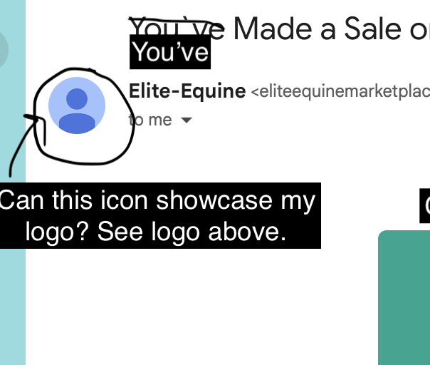

* **~~Thank You For Subscribing:~~**
* **Password Reset** - should say Elite Equine, not EliteQueen - please share new example

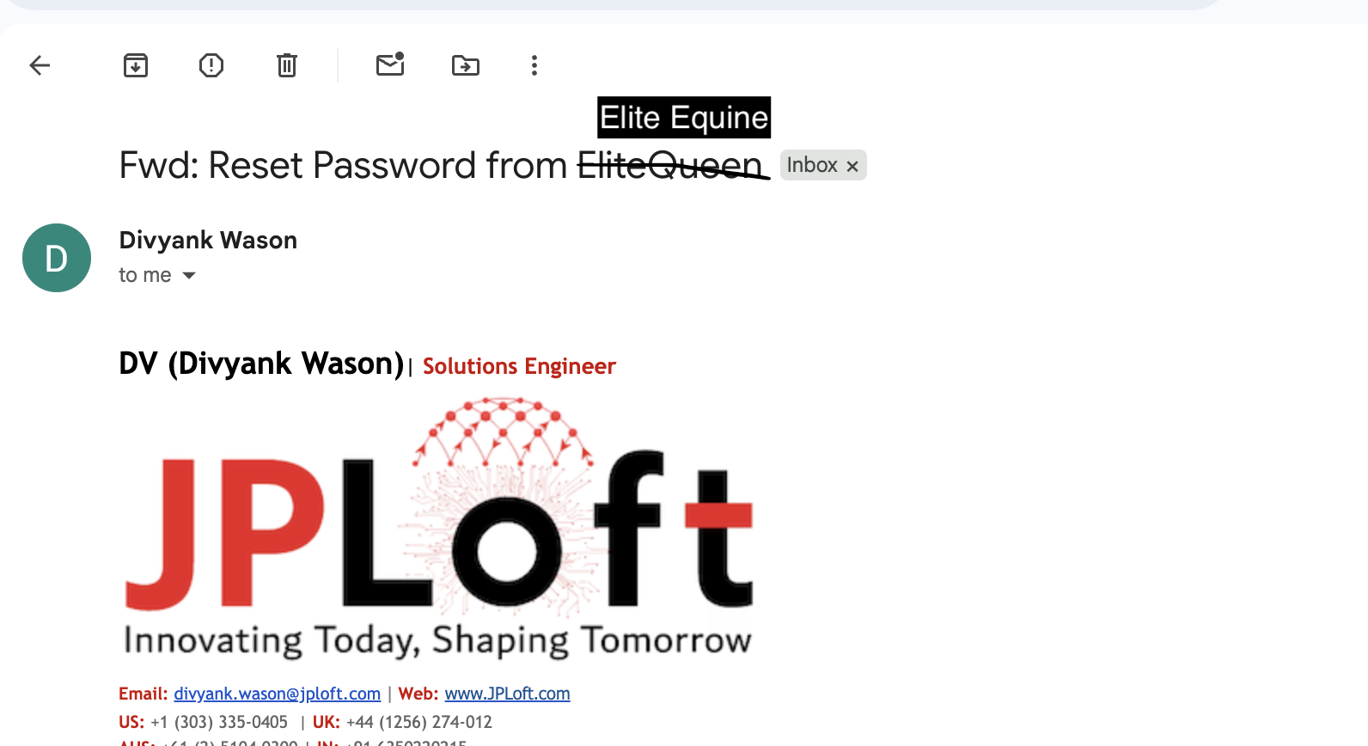

* **Saved Search Match -** please make these changes and share example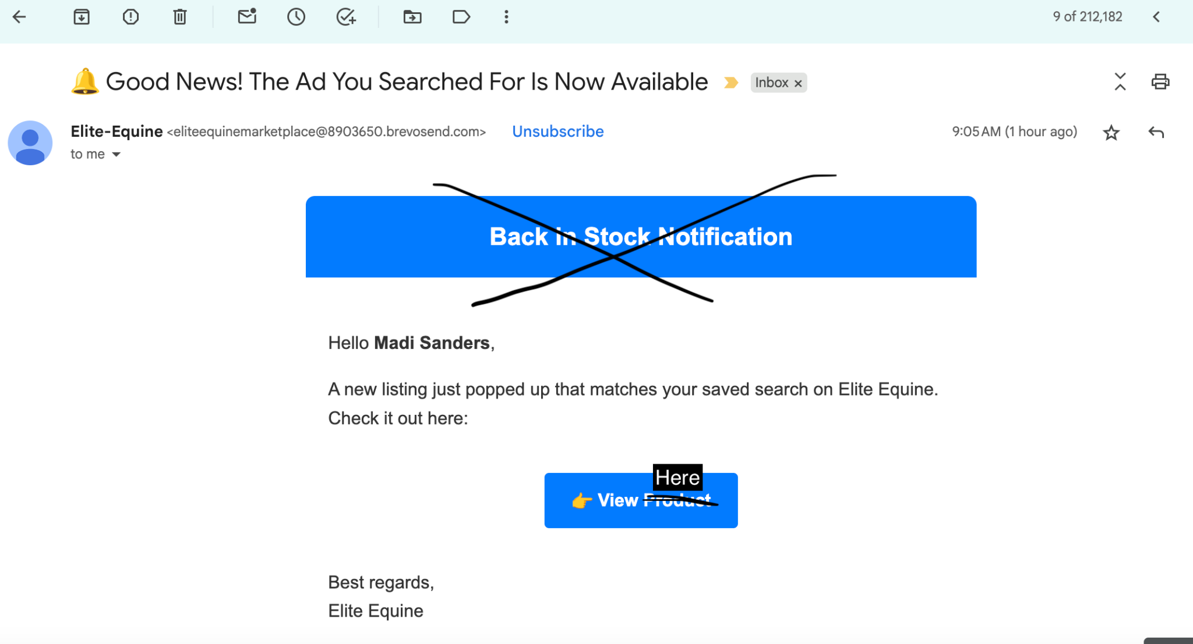
* **Auction Ending Soon -** please share this example

Email Title: **The Auction is Ending Soon on the Item You Bid On**

Hey {{Name}},

The auction is ending soon on the item you bid on. Go win it!

{{Insert Product Link}}

Best Regards,

Elite Equine

* **~~New Direct Message:~~**
* **Subscription Expiring -** please share with me this example

Email Title: **You**r **Elite Equine Subscription is Expiring**

Heads up, {{Name}}! Your Elite Equine subscription expires in 24 hours — your ads will be removed from the platform. Renew now to keep your listings live: {{Subscription Renewal Link}}

Best Regards,

Elite Equine

* **You’ve Made a Sale! -** see changes and share example 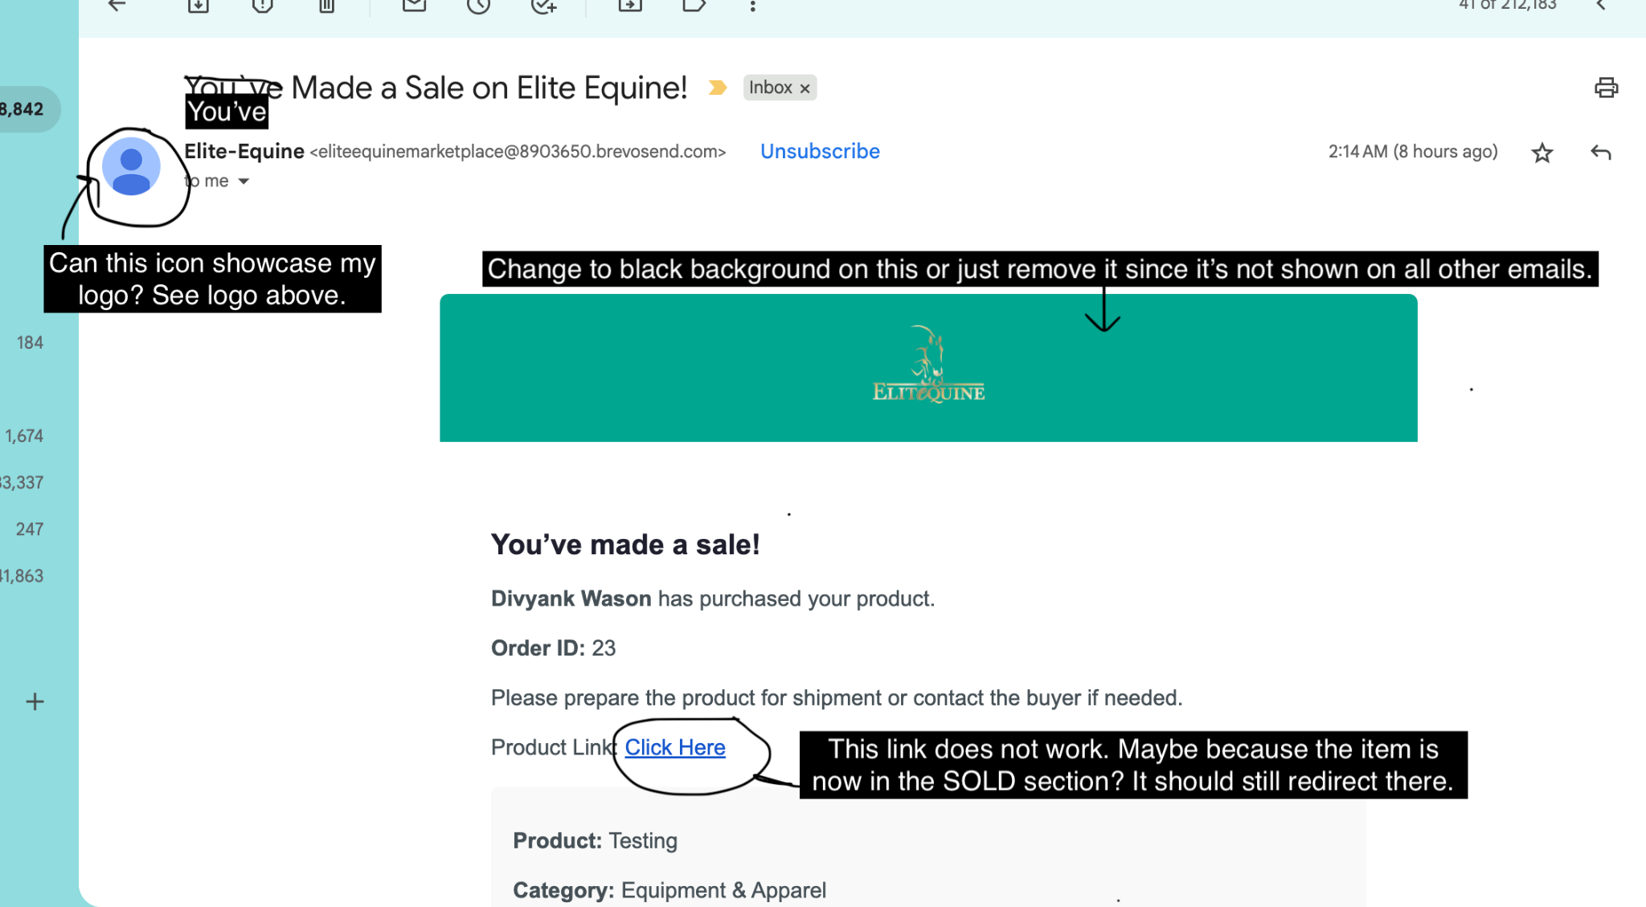
* **Auction SELLER -** instead of “Your Bid Closed”, just have it be the same exact content and email title as the “You’ve Made a Sale” above to keep things simple - please update and share example. 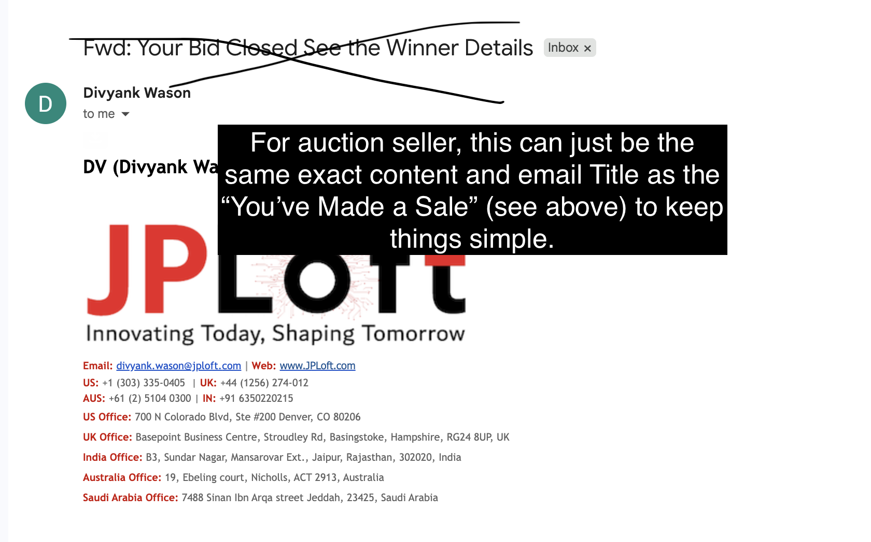
* **You are the Winning Bidder on Elite Equine! -** please update and share example

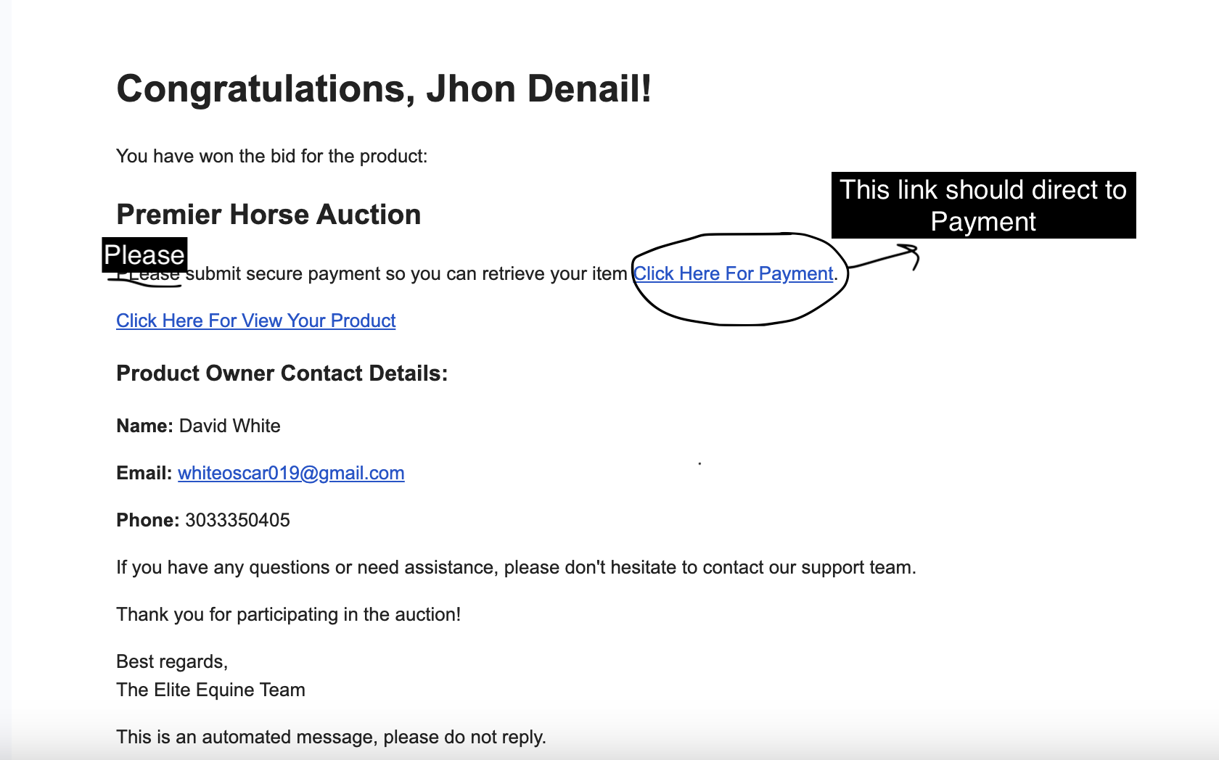

### **Messages TEXT & MOBILE APP NOTIFICATION:** please double check that all the links are working properly.

* **~~1. Saved Search Match~~***~~A new listing just popped up that matches your saved search on Elite Equine. Check it out here:~~* ~~{{Link to Ad}}~~
* **~~2. Auction Ending Reminder~~***~~The auction for an item you're bidding on is ending soon! Don’t miss your chance to win:~~* ~~{{Link to Auction Item Ad}}~~
* **3. New Direct Message** *You’ve received a new direct message on Elite Equine. Reply now:* {{Link to Direct Message / Inbox}}
* **~~4. Subscription Expiring~~***~~Heads up! Your Elite Equine subscription expires in 24 hours — your ads will be removed from the platform. Renew now to keep your listings live:~~* ~~{{Subscription Renewal Link}}~~
* **5. Payment Received - Time to Ship***Good news! You’ve received a secure payment via Stripe for your item. Please mark the item as “sold” and ship it to the buyer:* {{Link to Ad}}
* **6. You are the Winning Bidder!***Congrats! You’re the winning bidder on Elite Equine. Please submit secure payment so you can retrieve your item {{Link to Ad/Payment}}*

**All links should be embedded to take users directly to the relevant ad, subscription renewal, or inbox message.**